MIRRIS Coaching Seminar
Mobilizing Institutional Reform for Research and Innovation Systems

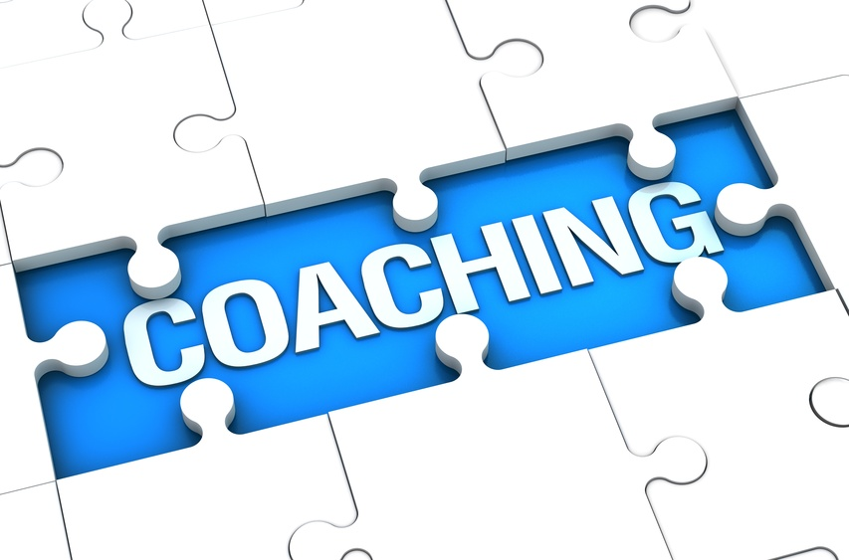

The research leading to these results has received funding from the European Union Seventh Framework Programme (FP7/2007-2013) under agreement n°3

AGENDA

15 March 2016, Zagreb, Croatia
10.00 – 10.15  10.15 – 10.30  10.30 - 11.30 | Welcome  Croatian Ministry of Science, Education and Sport  MIRRIS representative  Who is who in the audience (Tour de table)  Challenges to be faced and expected results (hosting organization)  Croatian Ministry of Science, Education and Sport  Presentation of the Case study- Establishment of EU support/TTO office  Presentation of the process, tools, related actions and implementation, list of critical points from the presentation  Stijn Delauré, KU Leuven  Q&A  Coffee break
12.15. – 13.15  13.15 – 14.00  14.00-15.30  15.30-16.00 | What to do and to avoid in the given context? Common assessment of the transferability of the tool  Stijn Delauré, KU Leuven  All participants  Lunch break  Roadmap and milestones for the implementation  Filling the Public Support Business Model Canvas  Stijn Delauré, KU Leuven  All participants  Conclusions and milestones for next steps  Stijn Delauré, KU Leuven  All participants

